RAMOS, JENNYLYN ANNE O.

BSIT 4A

**Assignment #1**

Case Questions:

**Chosen Company: Uber**

**1. How they use Microservices?**

Answer: Uber offers various features such as ride-sharing, scheduling a ride, fare splits, real-time tracking, varied forms of payment, safety measures, and many more. Therefore, with such rapid user’s growth, scalability became much easier using microservices. It's an architecture whereby teams are able to work on specific services that have problems so that they will develop faster without affecting the performance of other services in the system. The services have strictly defined rules with metrics ensuring that the reliability, consistency, and performance are optimized in the overall system.

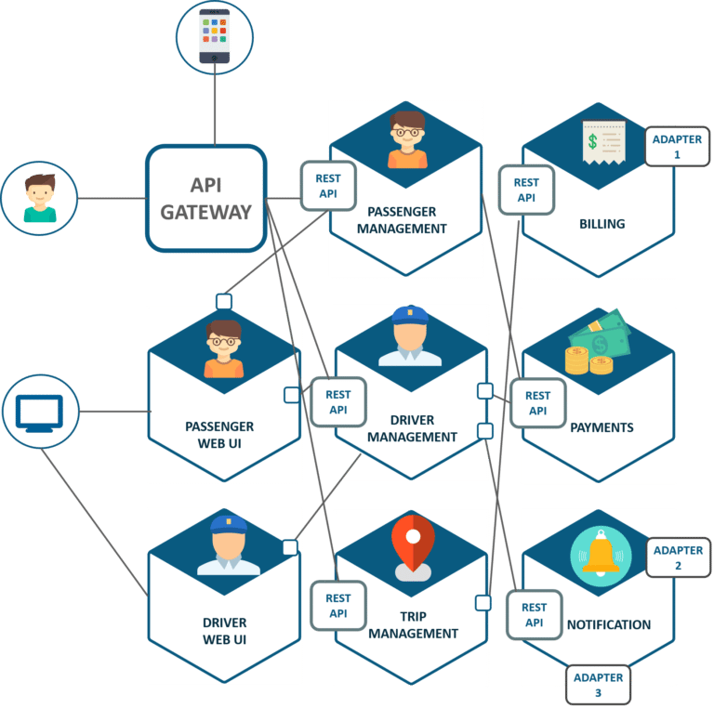

**2. Microservices in Architecture**

Answer:

As you can see, based on the figure, the API gateway is responsible for updating client services, meaning it operates automatically—it's like generating an operation on the spot. The API gateway serves as the main source of this system because it navigates everything, so it is used only once. That's the benefit of this setup. However, if an issue arises with the system, you have to start from the beginning again, and it becomes a trial-and-error process.

Microservices, are also efficient. If you need to adjust data like payments or billing, only those two areas will be affected, while the rest remain untouched. This modularity ensures the smooth running of the system. The REST API, as depicted, connects the client and the system or the drive, keeping everything integrated.

As illustrated, features like payment, notifications, and others are all on a single framework. The strength of this design is that each function works independently, with no overlapping commands or data. For instance, as seen in school portals, the system can handle multiple tasks without causing the site to crash. It efficiently manages all incoming requests and allows each service to perform its task without affecting others, maintaining the stability of the entire platform.

**3. Impact on Business and Scalability**

Answer:

* **Impact on Business** – The uber's move to microservices has improved the operational efficiency of their system. The different development teams can upgrade their respective services without affecting other services in the process. That way, uber improved the speed, quality, performance, and manageability of development for new features for the application. It also improved the fault tolerance of the system, thus making it more reliable to all users.
* **Scalability** – In terms of scalability, Uber’s growth is supported by the microservices architecture. Currently, Uber has 149 million customers using the platform and is served by 7.1 million drivers. As the company experienced rapid growth, the microservices allowed the services to function individually to not affect each other when problems came up with specific services. Their transition to micorservices has allowed Uber to handle the demand for specific services and accommodate the growth of their users.

**4. Challenges and Solutions**

Answer:

**Challenges Faced by Uber**

Uber encountered several significant challenges with its monolithic software framework:

* When updating even a single feature, every feature had to be built again, deployed and tested many times to make sure it has no problem.
* With a single codebase, fixing bugs was challenging, as developers had to repeatedly modify the same repository, increasing the risk of introducing new issues.
* Scaling features while introducing new ones across various countries became increasingly complex, hindering Uber’s ability to grow efficiently.

**Solutions:** To solve these challenges, Uber adopted a microservices architecture inspired by industry leaders like Amazon and Netflix. It shifted from one codebase to several codebases where every single microservice is expected to focus on a specific business function. Uber transformed its monolithic application into cloud-based microservices by linking each application through an API gateway.

**5. Lesson Learned from the said companies**

Answer: From understanding how Uber uses microservices, I learned that microservices are very helpful in preventing problems in a system. Also, microservices make the system more reliable and improve its performance for users. Uber taught me if you want your system to handle fast growth, make sure you are using the best solution that will help your business run smoothly.

**References:**

* Sayone Technologies. (n.d.). *A look at the Uber Microservices architecture*. <https://www.sayonetech.com/blog/look-uber-microservices-architecture/>
* H, J. (2024, September 11). 4 Microservices Examples: Amazon, Netflix, Uber, and Etsy. *4 Microservices Examples: Amazon, Netflix, Uber, and Etsy*. <https://blog.dreamfactory.com/microservices-examples#:~:text=To%20overcome%20the%20challenges%20of,%2C%20trip%20management%2C%20and%20more>.